Practical No. 5
Aim : 1) WAP that takes number and checks whether it is a pallindrome or not.

Name : Danish Altaf Solkar | Class : CO - B
Enrolment no. : 24111590805 | Batch : 2

Code :-
num = int(input("Enter a number : "))
original = num #Store the original number
reverse = 0
#Reverse the number
while num > 0 :
digit = num % 10
reverse = reverse * 10 + digit
num = num // 10
#Check pallindrome
if original == reverse :
print("The number is Pallindrome")
else :
print("The number is not Pallindrome")

OUTPUT :-
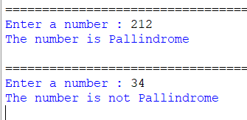

Practical No. 5
Aim : 2) WAP to print all even numbers between 1 to 100 using while loop

Name : Danish Altaf Solkar | Class : CO - B
Enrolment no. : 24111590805 | Batch : 2

Code :-
num = 2
#loop until 100
while num <= 100 :
print(num)
num = num + 2

OUTPUT :-
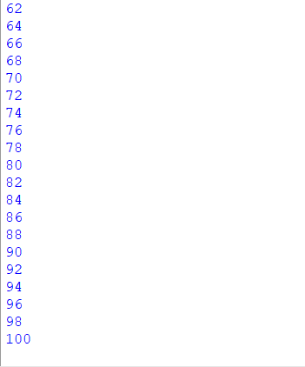

Practical No. 5
Aim : 3) Print the following patterns using loop

Name : Danish Altaf Solkar | Class : CO - B
Enrolment no. : 24111590805 | Batch : 2

- 1010101
10101
101
1

Code :-
rows = 4
length = 7
for i in range (rows) :
for j in range (length) :
if j % 2 == 0 :
print("1",end = " ")
else :
print("0",end = " ")
print ()
length -= 2

OUTPUT :-
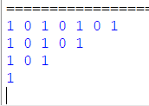

- *
***
******
***
*

Code :-
#upper half including middle
for i in range (1,6,2) :
print("*",i)

#lower half
for j in range (3,0,2) :
print("*"*i)

OUTPUT :-
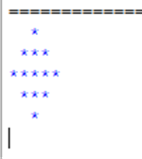
Practical No. 5
Aim : 4) Change the following python code from using a while loop to for loop

Name : Danish Altaf Solkar | Class : CO - B
Enrolment no. : 24111590805 | Batch : 2

Code :-
for x in range (1,10) :
print(x,end = " ")

OUTPUT :-
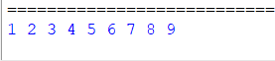

Aim : 5) WAP to reverse a given number

Code :-
num = int(input("Enter a number : "))
reverse = 0
while num > 0 :
digit = num % 10
reverse = reverse * 10 + digit
num = num // 10
print("Reversed number : ",reverse)

OUTPUT :-
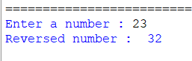

Practical No. 5
Aim : 6) WAP to find factorial of given number

Name : Danish Altaf Solkar | Class : CO - B
Enrolment no. : 24111590805 | Batch : 2

Code :-
num = int(input("Enter a number : "))
fact = 1
for i in range (1,num + 1) :
fact = fact * i
print("Factorial : ",fact)

OUTPUT :-
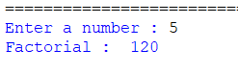

Aim : 7) WAP to find Fibonacci series for given number

Code :-
n = int(input("Enter the number of terms : "))
a,b = 0,1
print("Fibonacci Series : ")
for i in range (n) :
print(a,end = " ")
a,b = b, a + b

OUTPUT :-
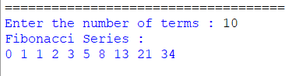

Practical No. 5
Aim : 8) Find sum of four digit number

Name : Danish Altaf Solkar | Class : CO - B
Enrolment no. : 24111590805 | Batch : 2

Code :-
num = int(input("Enter a four-digit number : "))
sum = 0
while num > 0 :
digit = num % 10
sum = sum + digit
num = num // 10
print("Sum of digits : ",sum)

OUTPUT :-
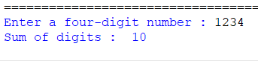

Process related  (30) | Product related  (20) | Total Marks  (50) | Signature

